WEEK-4 PROJECT REPORT

TELECOM DATA GOVERNANCE & SECURITY

Internship Domain:
Telecom Data Governance & Security
Duration:
6 Weeks
Submitted by:
DUDATI RASIKA
Week:
Week4 - Telecom Data Lifecycle Management and Archiving

1. Introduction
Telecom organizations generate large amounts of data through customer registration, billing, service usage, calls, data consumption and operational activities. Managing this information only during its active use is not sufficient. Data must be controlled throughout its complete lifecycle, starting from creation and ending with secure disposal.
Telecom Data Lifecycle Management and Archiving, a dedicated Data Lifecycle Management module was implemented in the Flask-based Telecom Data Governance & Security Management System.
The implemented module provides a structured representation of the telecom data lifecycle:
Data Creation → Data Collection → Data Storage → Data Usage → Data Archiving → Secure Disposal
The practical implementation also includes sections for Data Retention & Archiving, Lifecycle Management Rules, Backup & Recovery, Lifecycle Audit & Monitoring, and Recommendations.
The purpose of the implementation is to demonstrate how telecom data can be governed throughout its lifecycle and how lifecycle-related controls can be incorporated into a centralized governance application.

2. Objectives
The main objectives of:
- To design a structured telecom data lifecycle.
- To identify the major stages of data management.
- To define data retention and archival controls.
- To establish secure disposal procedures.
- To define backup and recovery practices.
- To explain lifecycle monitoring and auditing.
- To document how lifecycle-related incidents can be handled.
- To implement the lifecycle framework as a Flask web module.
- To integrate the module with the main governance dashboard.

3. Practical Implementation
The module was implemented as a separate Flask page:
</>plain text
templates/lifecycle.html

The corresponding Flask route is:
</>python
@app.route("/lifecycle")
@role required(
"Admin",
"Data Manager",
"Compliance Officer",
"Security Officer",
"Viewer"
)
def lifecycle():

return render_template(
"lifecycle.html"
)

The module can be accessed through:
</>plain text
http://127.0.0.1:5000/lifecycle

4. Data Lifecycle Implemented in the Application
The practical webpage contains six main lifecycle stages.
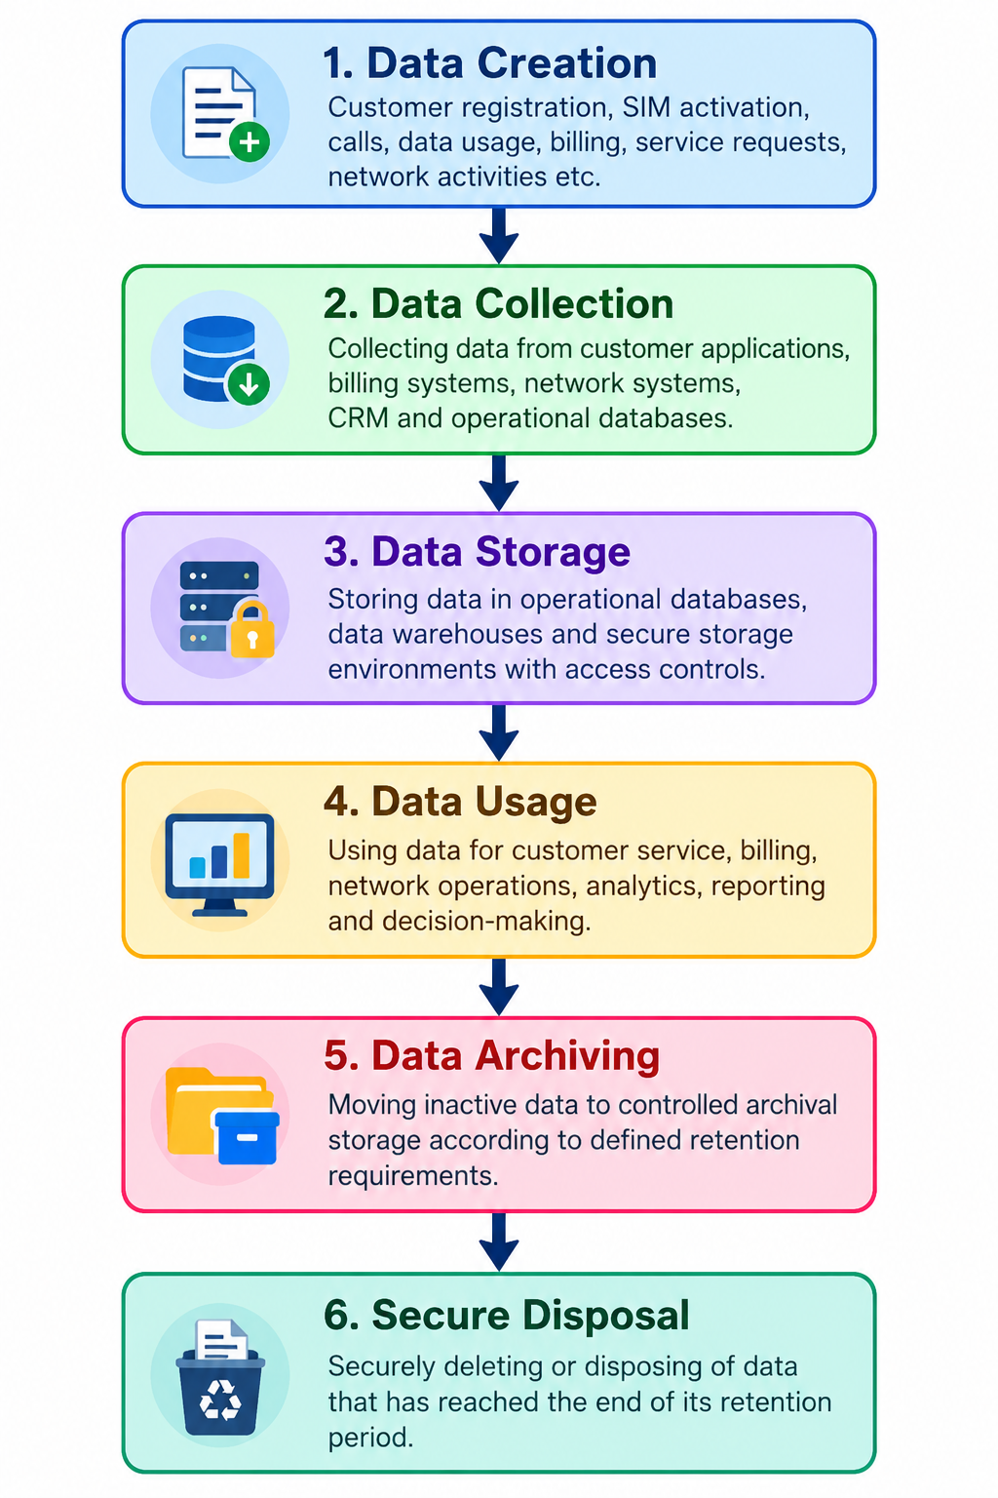
5. Data Creation
The first section of the implemented lifecycle module is Data Creation.
The module explains that telecom data can be generated through:
- Customer registration
- SIM/service activation
- Phone calls
- Internet/data usage
- Billing transactions
- Customer service interactions
- Network operations
- Service requests
- Account updates
Practical Example
When a new telecom customer registers, information such as:
Customer ID
Phone Number
Customer Status
Service Plan
Activation Information
Billing Information
may be created.
6. Data Collection
The second implemented stage is Data Collection.
Telecom information may be collected from:
- Customer applications
- Billing systems
- Network systems
- CRM systems
- Service platforms
- Operational databases
The practical framework identifies the need to validate collected information before it enters downstream systems.
For example, validation can identify:
- Missing values
- Duplicate records
- Invalid values
- Incorrect formats
- Incomplete records
7. Data Storage
The third lifecycle stage is Data Storage.
The implemented module explains that telecom information may be stored in:
- Operational databases
- Application databases
- Data warehouses
- Backup systems
- Archive storage
The lifecycle page identifies important controls such as:
- Access control
- Encryption
- Authentication
- Backup
- Monitoring
- Audit logging
8. Data Usage
The fourth stage is Data Usage.
Telecom data can be used for:
- Customer service
- Billing
- Network operations
- Analytics
- Reporting
- Service management
- Performance monitoring
The application framework connects data usage with role-based access control.

For example:
Role | Relevant Responsibility
Admin | System administration
Data Manager | Data management and quality
Security Officer | Security controls
Compliance Officer | Governance and compliance
Viewer | Approved read-only access

9. Data Retention and Archiving
The implemented lifecycle page contains a dedicated Data Retention & Archiving section.
The purpose is to ensure that data is not retained indefinitely without a valid reason.
The framework considers:
- Business requirements
- Operational requirements
- Security requirements
- Compliance requirements
- Historical requirements
Practical Archiving Workflow
Identify inactive data
↓
Check retention requirement
↓
Check whether data is still required
↓
Authorize archival
↓
Move to controlled archive
↓
Restrict access
↓
Review periodically
10. Lifecycle Management Rules
The practical implementation includes a Lifecycle Management Rules table.
Lifecycle Stage | Control | Purpose
Data Creation | Data classification | Identify sensitivity and ownership
Data Storage | Access control and encryption | Protect stored information
Data Usage | Role-based access | Restrict unauthorized usage
Data Archiving | Retention policy | Preserve required information
Data Disposal | Secure deletion | Prevent unauthorized recovery

11. Backup and Recovery
The implemented page contains a Backup & Recovery section.
The framework recommends:
- Maintaining regular backups.
- Storing backup copies in controlled environments.
- Restricting backup access.
- Testing restoration procedures.
- Maintaining recovery procedures.
Practical Scenario
Consider a telecom database failure.
Database Failure
↓
Identify Failure
↓
Activate Recovery Procedure
↓
Restore Approved Backup
↓
Verify Data Integrity
↓
Resume Normal Operations

12. Lifecycle Monitoring
This section directly addresses the evaluator's feedback about "how monitoring works in practice."
The implemented lifecycle framework identifies monitoring as an ongoing governance activity.
A real implementation can monitor:
Monitoring Area | What is Checked
Data Storage | Unauthorized access
Archiving | Archive operations
Retention | Records approaching expiry
Backup | Backup success/failure
Disposal | Approved disposal activities
Access | User access to lifecycle information
Audit | Governance compliance

Example Monitoring Scenario
Suppose a system identifies that a group of records is approaching its retention limit.
The monitoring workflow would be:
Retention threshold reached
↓
Generate review requirement
↓
Data owner reviews records
↓
Continue retention OR archive
↓
If retention expired → disposal review

13. Lifecycle Auditing
The implemented page also contains a Lifecycle Audit & Monitoring section.
Auditing verifies whether the lifecycle controls are actually being followed.

Practical Audit Process
Define Audit Scope
↓
Collect Evidence
↓
Review Retention Rules
↓
Review Archive Activities
↓
Check Access Records
↓
Review Disposal Records
↓
Identify Exceptions
↓
Assign Corrective Action
↓
Verify Corrective Action
Example
An auditor may review:
- Whether archived information has an identified owner.
- Whether retention requirements are documented.
- Whether access is restricted.
- Whether disposal activities are authorized.
- Whether lifecycle policies are being followed.

14. Incident Response Related to Lifecycle Management
The evaluator specifically requested a more detailed explanation of incident response.
Although the module focuses on lifecycle management, lifecycle incidents can occur.
Example Incident
An unauthorized user attempts to access archived customer information.
The response process would be:
Incident Detected
↓
Identify affected data
↓
Classify incident
↓
Restrict unauthorized access
↓
Investigate logs
↓
Remove cause
↓
Restore secure operation
↓
Document incident
↓
Improve lifecycle controls
Incident Response Activities
Identification:
Determine what happened, when it happened and which information may have been affected.
Containment:
Restrict the affected account, archive or system to prevent further unauthorized access.
Investigation:
Review available access and authentication records.
Correction:
Remove inappropriate permissions or correct the configuration that caused the incident.
Recovery:
Verify that the affected system is operating securely.
Lessons Learned:
Update lifecycle controls to reduce the possibility of recurrence.
15. Concrete Practical Metrics
To address the evaluator's request for concrete numbers, the lifecycle system can use measurable governance metrics.
For example:
KPI | Measurement
Archive Review Rate | Reviewed records ÷ records due for review × 100
Retention Compliance | Compliant records ÷ reviewed records × 100
Backup Success Rate | Successful backups ÷ scheduled backups × 100
Disposal Compliance | Authorized disposals ÷ completed disposals × 100
Audit Closure Rate | Closed findings ÷ total findings × 100

Example Calculation
Suppose:
- 100 records were due for lifecycle review.
- 95 were reviewed.
Then:
Archive Review Rate = 95 ÷ 100 × 100 = 95%
This provides a measurable way to evaluate lifecycle governance.
16. Practical Technology Implementation
The module was implemented using:
Technology | Usage
Python | Backend programming
Flask | Web application framework
HTML | Lifecycle webpage
CSS | User interface
VS Code | Development
Git/GitHub | Version control
CSV | Project data source

17. Results of Practical Implementation
The implementation successfully produced a dedicated Data Lifecycle Management webpage containing:
Lifecycle stages
✅ Data Creation
✅ Data Collection
✅ Data Storage
✅ Data Usage
✅ Data Archiving
✅ Secure Disposal
Supporting controls
✅ Retention & Archiving
✅ Lifecycle Management Rules
✅ Backup & Recovery
✅ Lifecycle Audit & Monitoring
✅ Recommendations
Application integration
✅ Flask route
✅ Dashboard integration
✅ Role-based access
✅ Back to Dashboard navigation
18. Limitations
The current implementation is a working governance prototype, not a complete enterprise telecom data management platform.
Currently, the application does not automatically:
- Move records to an archive database.
- Calculate real retention expiry dates.
- Perform actual secure deletion.
- Execute production backup jobs.
- Generate automatic lifecycle alerts.
- Maintain a complete database-backed audit trail.
- Automatically calculate lifecycle KPIs from production data.
19. Future Enhancements
The next version of the system can include:
- Database-based lifecycle tracking.
- Automatic retention-date calculation.
- Archive database integration.
- Approval-based disposal.
- Automatic retention alerts.
- Real-time lifecycle monitoring.
- Complete audit-log database.
- Automated backup integration.
- Lifecycle KPI dashboard.
- Incident notification system.
20. Conclusion
The implementation established a structured Telecom Data Lifecycle Management and Archiving framework within the Telecom Data Governance & Security Management System.
The practical implementation covers the complete conceptual lifecycle from data creation to secure disposal and provides supporting controls for retention, archiving, backup, recovery, monitoring and auditing.
To address the identified evaluation feedback, the report provides concrete examples, measurable KPI formulas, practical monitoring procedures, an audit workflow and a detailed lifecycle-related incident response process.
The current Flask implementation demonstrates the governance framework and user interface, while future development can extend it into an automated lifecycle management system using a database, real-time monitoring, audit logging and automated retention workflows.

